Ideation Phase
Brainstorm & Idea Prioritization

Date | 25 September 2026
Team ID | SWTID-2026-7212
Project Name | AI Study Buddy
Maximum Marks | 4 Marks

Brainstorm & Idea Prioritization :
The brainstorming process for AI StudyBuddy focused on identifying the main challenges students face during exam preparation. Several ideas were discussed, including AI-based summaries, flashcards, quizzes, personalized study plans, study history, and secure user authentication. These ideas were then prioritized based on their usefulness, ease of implementation, and impact on student learning. The main priority was given to AI summary generation, followed by quizzes, flashcards, personalized study plans, and saved learning resources.
Step-1: Team Gathering, Collaboration and Select the Problem Statement
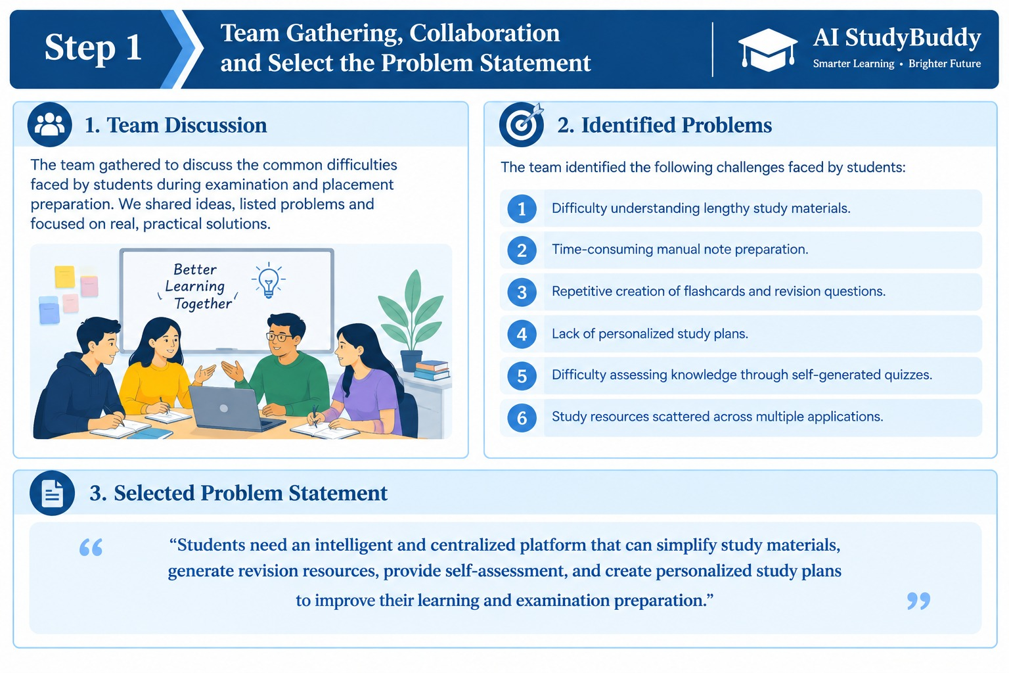

Step-2: Brainstorm, Idea Listing and Grouping
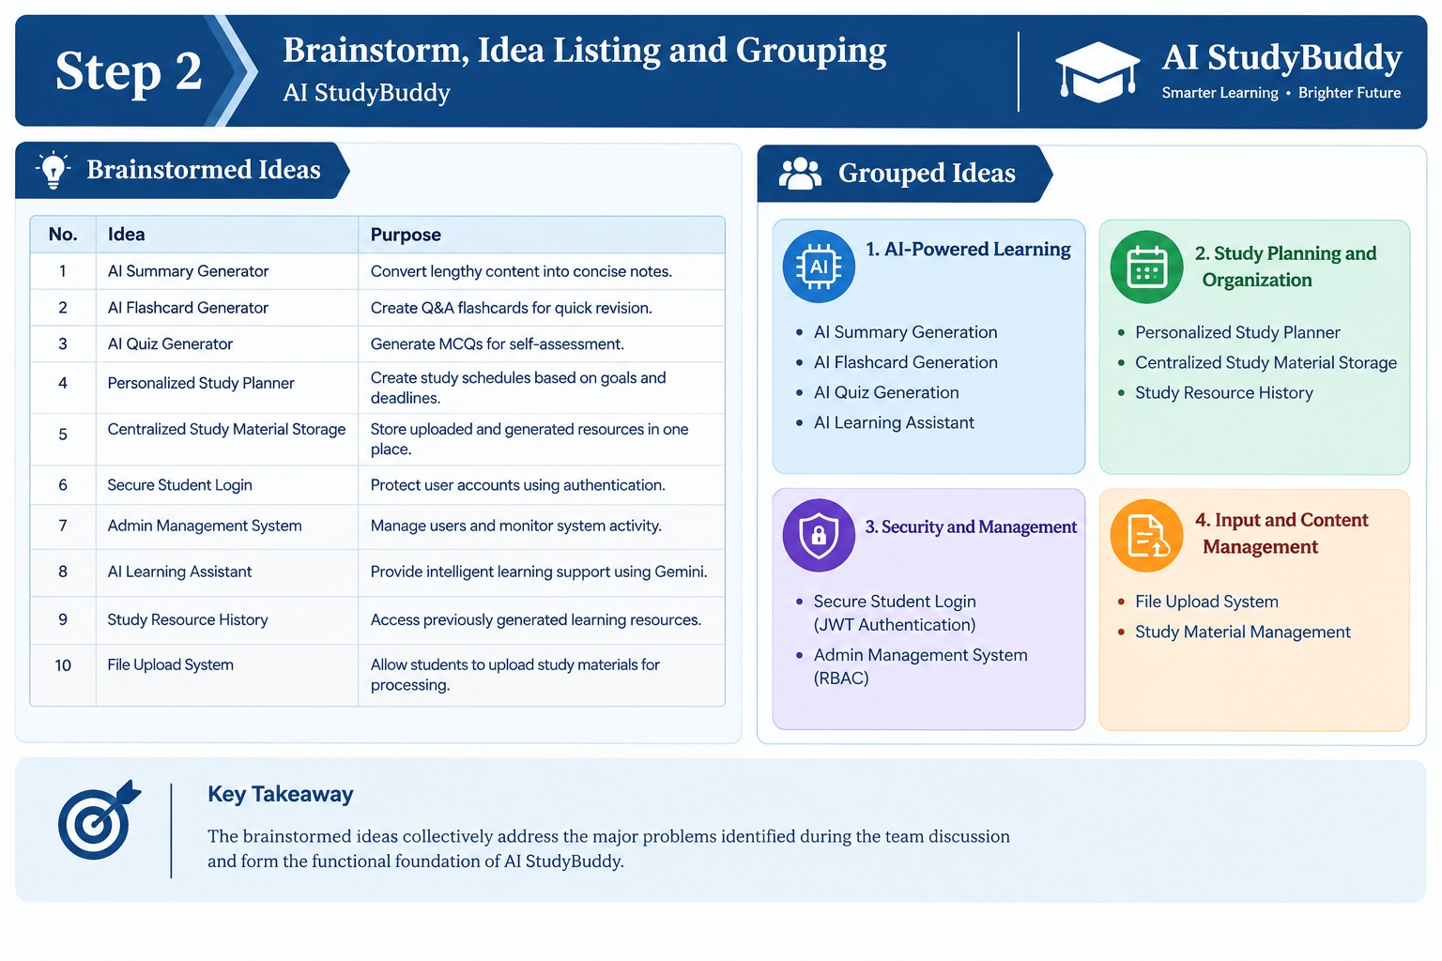

Step-3: Idea Prioritization
